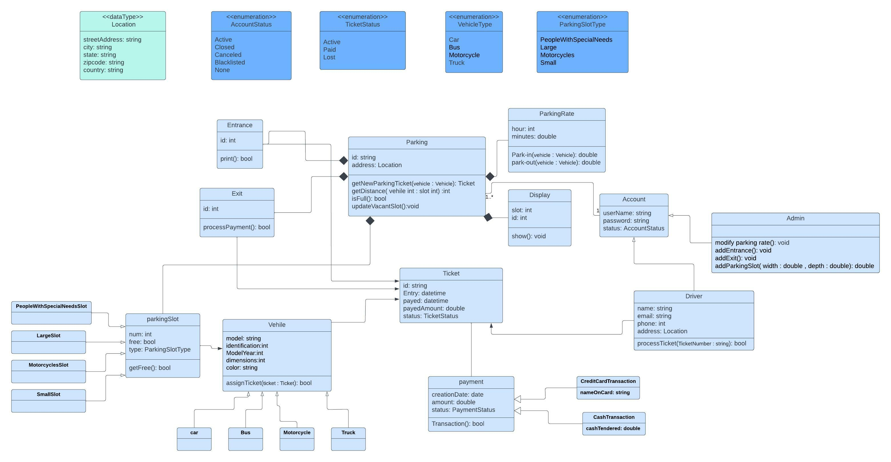

|  |  |  |
| --- | --- | --- |
| Class ID | Class Name | Description & Responsibility |
| 1 | Parking | This main part of the application which is designed, it contains all the information related to the garage, it has attributes like "id" to distinguish it from any other parking and "address" to locate it, it also has the function of "getNewParkingTicket" for me to get a new ticket, and also "getDistance" for me to get the closest slot to the entrance, "isFull" for me to see if my garage is full or not, and "updateVacantSlot" if the reservation is cancelled, updates the number of vacant slot. |
| 2 | ParkingRate | This class will track hourly parking rates. An amount of 5 Egyptian pounds will be set for each hour, and it has features such as "hour" and "minutes", and it also has a "Park-in" function that determines the time of arrival of the car and the time of its departure from the garage. |
| 3 | Account | We have two types of accounts, the admin is able to modify the price of the slot and add an entrance or exit and a slot, and the other contains all the information related to drivers name, phone number, email, password and account status. |
| 4 | Vehile | Contains all vehicle specifications (model, identification, Model Year, dimensions, color). Vehicles will be parked in the parking spaces. Our application will support different types of vehicles, "car", "Bus", "Motorcycle", "Truck" |
| 5 | parkingSlot | Each parking lot will have a parking space. Our application will support different parking spaces ، "PeopleWithSpecialNeedsSlot", "LargeSlot", "MotorcyclesSlot", "SmallSlot". |
| 6 | Ticket | This class will encapsulate a parking ticket. drivers will collect a ticket when they enter the garage. |
| 7 , 8 | Entrance , Exit | class Entrance will print tickets, and class Exit will facilitate payment of the ticket fee. |
| 9 | Display | Display the available parking slots. |
| 10 | payment | This class will be responsible for making payments. The application will support credit card and cash transactions. |